**Getting Started With Gmail**

# Why Gmail?

Gmail is the email client from Google.Signing up for Gmail provides benefits that may not be available with your current email client, including:

* Spam filtering.
* Video conferencing, phone calls, and chat.
* The ability to check your email account using services like Outlook or Apple Mail
* Search feature for both email messages and text chat conversations.

# Signing up for Gmail

You’ll need:

* A laptop or desktop computer.
* An open web browser (Google Chrome, Mozilla Firefox, Internet Explorer, Microsoft Edge, etc).

## **To sign up for Gmail**

1. In your browser, navigate to https://www.google.com/gmail/about/.
2. The “Create An Account” window appears.
3. Fill in all of your account information and click the “Next Steps” button.

Your email address should be unique and memorable. Your password should be unique, memorable, and strong. Strong passwords:

* + Are at least 8 characters long.
  + Combines letters, numbers, and symbol characters within the password.
  + Are not found in a dictionary.
  + Are not the name of a command.
  + Are not the name of a person.
  + Are not the name of a user.
  + Are not the name of a computer.
  + Are changed regularly.
  + Are significantly different from previous passwords.

1. Agree to the terms of service that appear in the center of the screen.
2. Click the “Continue to Gmail” button to open Gmail and view the Welcome walkthrough. At the conclusion of the walk-through, you have full access to your new email account.

# Importing your contacts and other mail

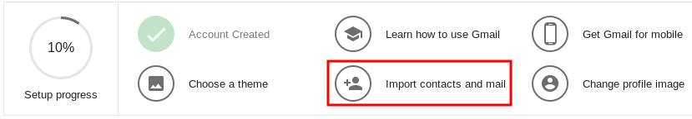

Importing your contacts and other mail from a previous email service makes it easy to pick up where you left off – no need to log into another service to hunt for old emails.

To import your contacts and email messages from a different account, do the following:

1. Click the “Import contacts and mail” option from the “Setup progress” menu, shown in the image above.
   * If you do not see the “Setup progress” menu, you can import your contacts by going to [https://contacts.google.com](https://contacts.google.com/).
   * Click “More.”
   * Click “Import.”
2. In the window that opens, enter the name of the email address you wish to import contacts from.
3. Enter the email address and password of the previous email account you listed in step 2.
4. Click “Allow.”
5. Close the window once it reads “Authentication successful.”

# Get Gmail for mobile

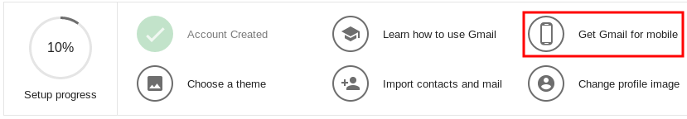

Having Gmail for mobile makes it easy for you to read and reply to your email at any time without needing to sit down in front of a computer.

You'll need:

* a mobile phone to get the mobile app.

To get the Gmail mobile application on your phone or tablet and begin using it, follow these steps:

1. Click the “Get Gmail for mobile” option from the “Setup progress” menu, shown in the image above.
   * If the “Setup progress” menu is not available, the Gmail app can be downloaded by going to [https://get.google.com/apptips/apps/#!/all](https://get.google.com/apptips/apps/" \l "!/all).
2. Choose one of the three choices below:
   * Enter your mobile number.
   * Scan the provided QR code.
   * Visit [www.gmail.com/app](http://www.gmail.com/app) on your mobile device’s web browser.

Entering your mobile number will send a link to the app via SMS to the number that you entered. Scanning the provided QR code will take you to the app store for the phone you’re using. Visiting [www.gmail.com/app](http://www.gmail.com/app) will take you to the mobile store associated with your device, where you can download the app.

1. Log in to the mobile application using the email and password that you created.

*For more information on how to use Gmail, click the “Learn how to use Gmail” option, which will open the Google Help menu.*